**NCP Lab 4**

**07/08/2020**

**Ragul S V**

**CB.EN.U4CSE17348**

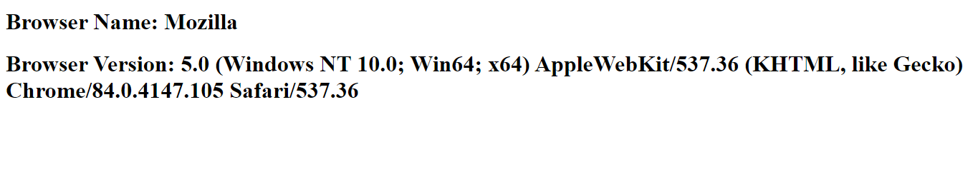**Q1)**

**Q2)**

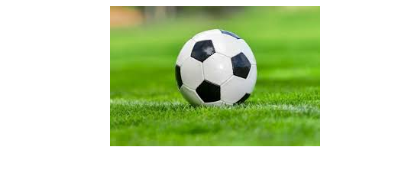

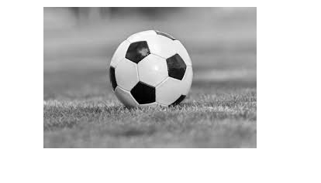

Default

Image:

On

Hover

Over:

On

Hover

Out:

**Q3)**

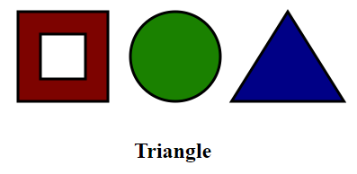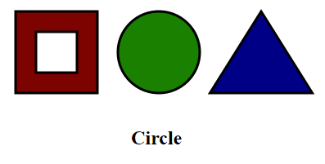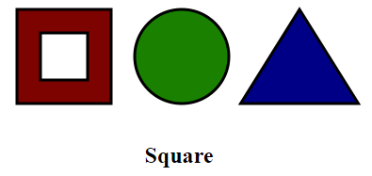

Hovering over

Square:

Hovering over

Circle:

Hovering over

Triangle:

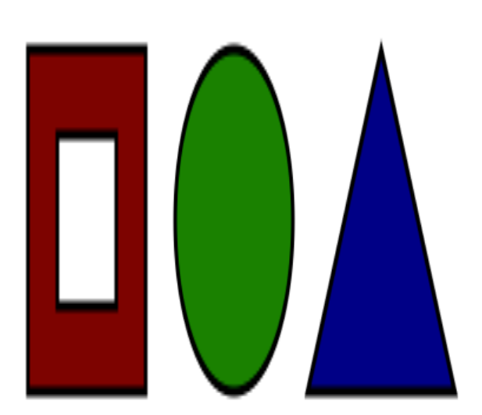

Enlarged Image

On clicked:

**Q4)**

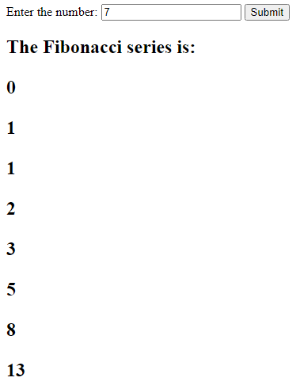

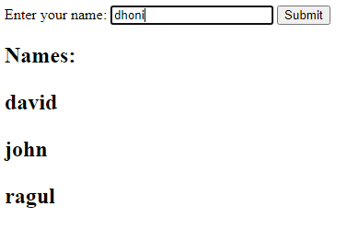**Q5)**

Before Entering a

Value:

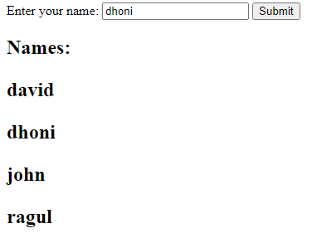

After Entering a

Value:

**Q6)**

